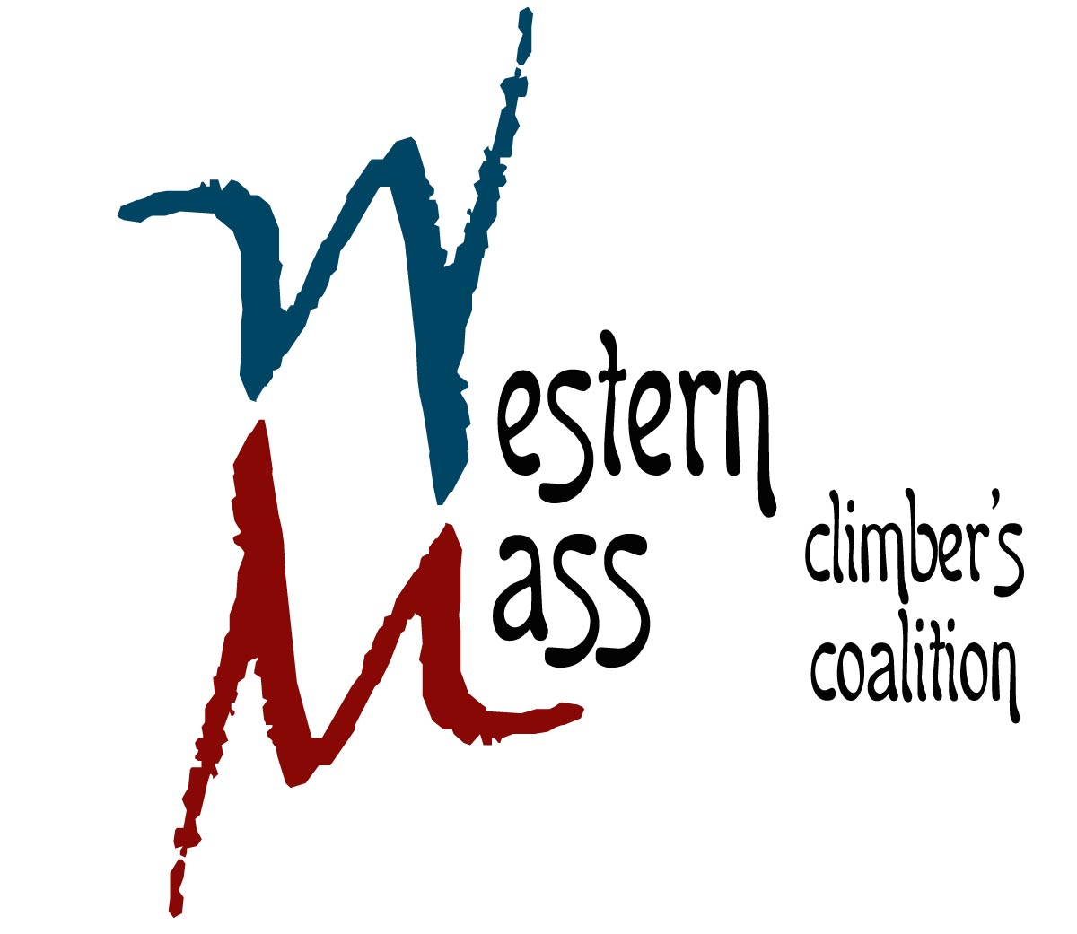
25 Parkview Drive
South Hadley, MA 01075
413.493.1974 www.climbgneiss.org

October 3, 2014

Rao’s Coffee
17 Kellogg Ave
Amherst, MA 01002

Dear Mr. Majka

On behalf of the Western Massachusetts Climbers’ Coalition (a registered 501c3, EIN #81-0548355), I would like to take this opportunity to thank you for supporting our organization and helping to protect and preserve climbing resources in Massachusetts.

Your generous donation of 200 brewed servings and 5 lbs of coffee to our Western Mass Rendezvous event (September 19th-21st, 2014) was an extraordinary gift that allowed us reach our fundraising goals!

Again, thank you for your support and we hope you’ll start training one-arm pull-ups again soon!

Sincerely,
Peter Clark

President
Western Massachusetts Climbers’ Coalition

